Ideation Phase
Empathize & Discover

Date | 31 January 2025
Team ID | LTVIP2026TMIDS65560
Project Name | Educational Organization Using ServiceNow
Maximum Marks | 4 Marks

Empathy Map Canvas:
An empathy map is a simple, easy-to-digest visual that captures knowledge about a user’s behaviours and attitudes.

It is a useful tool to helps teams better understand their users.
Creating an effective solution requires understanding the true problem and the person who is experiencing it. The exercise of creating the map helps participants consider things from the user’s perspective along with his or her goals and challenges.
Example:
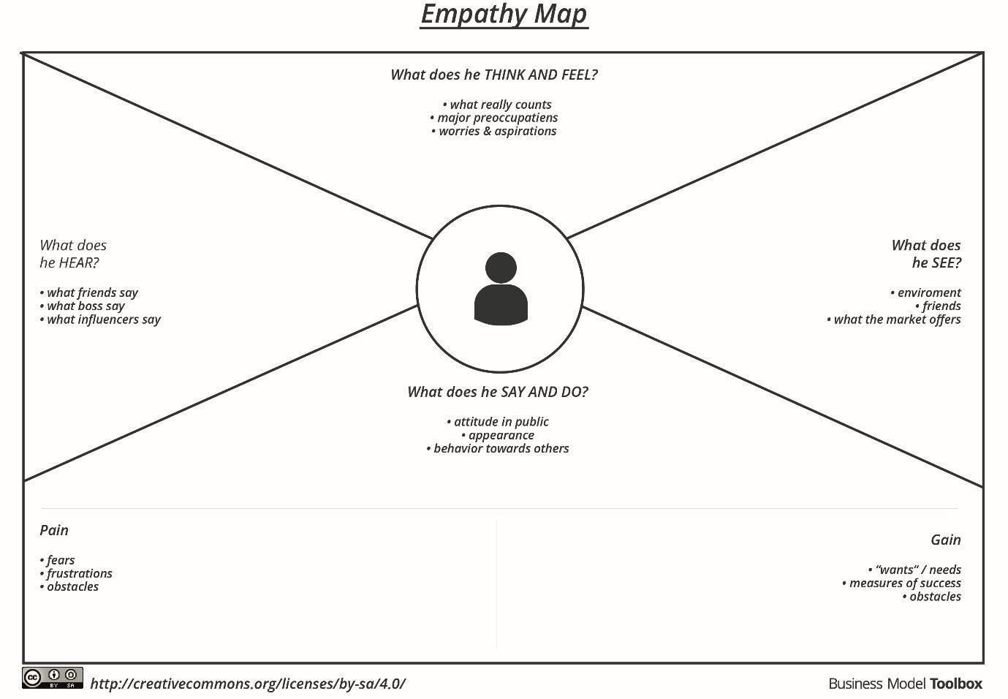

Reference: https://www.mural.co/templates/empathy-map-canvas

Example: Food Ordering & Delivery Application
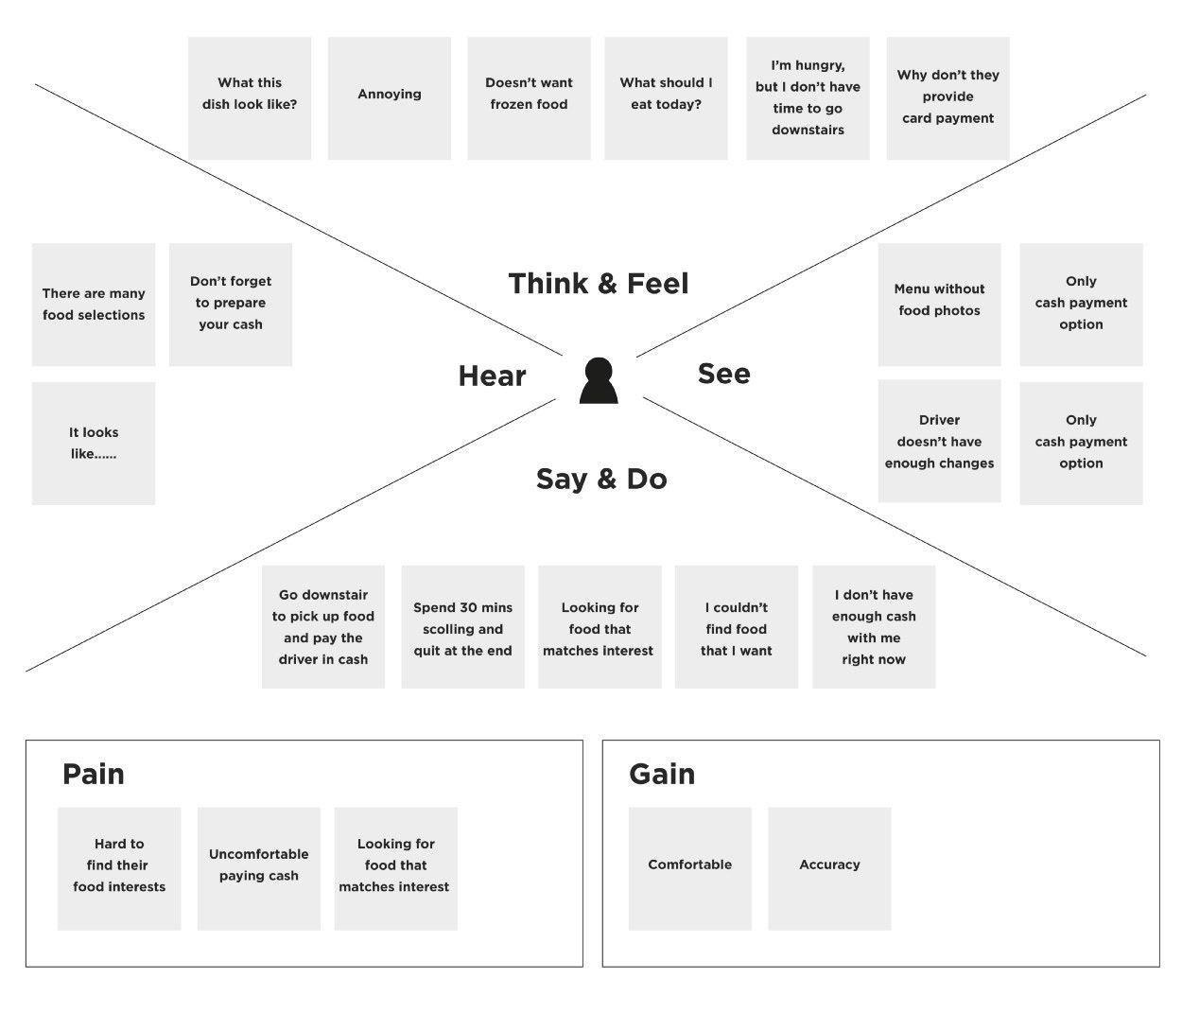

1. Says
- I need quick access to academic information.
- The admission and request process takes too long.
- I want everything in one place.
- It is difficult to track my application status.

2. Thinks
- The system should be simple and fast.
- Manual processes waste time.
- Digital services will make tasks easier.
- I need transparency in academic processes.

3. Does
- Submits forms and requests manually.
- Visits the administration office frequently.
- Checks multiple platforms for information.
- Waits for updates from staff.

4. Feels
- Frustrated due to delays.
- Confused by complex processes.
- Stressed about missing information.
- Unsatisfied with current system efficiency.

🎯 Goals
- Quick service request processing.
- Easy access to academic details.
- Centralized digital platform.
- Faster communication with administration.

